HISTORICAL DATA
The following figures are from the Operational Statistics Report provided by the Annual Conference for 2008-2013.
Jo-Ota 2008 2013
# ofGrps 69 132
UM Grps 47 90
New Camps 2 28
# of Churches 69 217
UMCs Summer 63 69
*85 in 2012
Campers 1576 3340
UM Campers 1070 1758
User Days 4516 7636

2012
All Sites % @ Jo-Ota
# ofGrps 360 39%
Um Grps 262 41%
New Camps 71 56%
# ofChurches 669 35%
UMCs Summer 393 22%
Campers 11369 30%
UM Campers 5848 31%
User Days 34098 23%
*Note Jo-Ota is the smallest of the 4 sites

Jo-Ota Financials
2012 Income $215,433
2012 Expenses $229,885
-$14,462

2013 Income $227,006
2013 Expenses $215,522
+$11,484
*Income vs. Expenses trending up!
BUDGETS
REALITY – is for summer camping season only without additional fund-raising.
INCOME
Trust $31,000
Camper fees* $39,060
Church Donations $5,000
Total Income $75,060
EXPENSES
Insurance $18,000
Utilities $18,550
Staff $30,100
Operational Costs $7,288
Total Expenses $73,938

ANNUAL – is for 12 months of operation. Includes reasonable funding goals and expenses.
INCOME
Membership Fees $7,500
Church Giving $52,500
User Fees $165,000
Private Donations $20,000
Trust/Endowed Funds $30,000
Total Income $275,000**
EXPENSES
Staff $133,000
Utilities $32,000
Program $5,000
Operations $24,000
Insurance $18,000
Maintenance $20,000
Total Expenses $243,000

*Camper fees based on average cost of rented facilities for 2015.

** Excess income divided between investments, capital improvements, and budget cushion.
OPERATIONAL PLAN
Membership in the JMA shall be active United Methodists and pay annual dues.

A Board of Directors of 9 sets policy, supervise staff, establish a balanced budget, & monitor goals.

Staff shall include: Site Director, Cook, Core Staff, Maintenance Supervisor, & Weekend Superintendent.

Work teams are formed to ensure effective and efficient ministry and include: Finance, Facility, Program, Staff Relations, & Promotions. Each team shall be led by 2 members of the board.

Camp Jo-Ota shall be open for operations 12 months out of the year.

Summer camping Season shall be
June 1-August 15.

Facility use policy & fee schedule shall be binding on all groups using the camp.

Camp Jo-Ota shall maintain ACA accreditation.

Protection of children, youth, and vulnerable adults will be a priority and Safe Sanctuary Policies shall be followed explicitly.

JMA shall be a registered 501c3 organization and maintain its own property and liability insurance.
PETITION HIGHLIGHTS
Whereas points:
- CRM Board is recommending no longer owning/operating property for camping
- No core camps currently north of I-70
- Camp Jo-Ota is a strategic property for accomplishing the mission of churches in the Mark Twain District.
- NEMO churches have contributed over $800,000 in 5 years and countless work hours.
- JMA formed to manage, maintain and operate the camp
- Trust Funds available for operation.
Therefore points:
- Return camp (no charge) to locals
- Equip/lead local church(s) to lead people to actively follow Christ through camping.
- JMA shall receive proceeds of Agnew Foundation Trust.
FURTHER RATIONAL
- No cost or liability to the Conference
- Provide leadership opportunities
- Provides core site for CMR camps
- Many UM pastors credit camp to hearing/developing call. W/O a regional camp in NEMO new calls to ministry will be harder to discern.

UMC Endorsements
Arbela Atlanta
Barker Bear Branch
Bee Ridge Bethel (Shelbyville)
Bethlehem Bluff Springs
Brashear Centenary (Lewistown)
Clarence Downing
Durham Edina
Evangelical (Brookfield)
First UMC (Hannibal, MO)
Grace (Madison) Granger
Hunnewell Hurland
Hydesburg Immanuel
Kendall LaGrange
La Plata Laclede
Linneus Lowman Chapel
Luray Macon
Meadville Memphis
Mendon Monticello
Mt. Olivet Mt. Vernon
Mt. Zion (West) Palmyra
Paris Park (Lewistown)
Pleasant Grove Sabbath Home
Shelbina Siloam Chapel
St. Francisville Sumner
Trinity (Brookfield) Wayland
Zion
*Each of these churches has given $50 in seed money to promote the association at Annual Conference and throughout NEMO.

*Once JMA is gifted the camp these churches pledge to continue financial support of the camp through annual giving and missional fundraising.
JO-OTA
METHODIST
ASSOCIATION

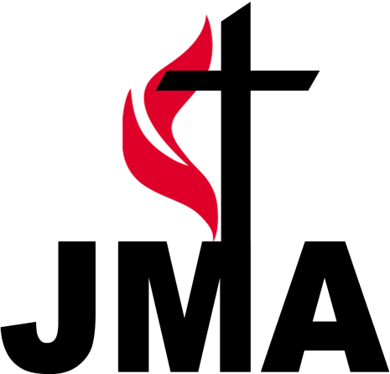

www.campjo-ota.org

We exist to make disciples of Jesus Christ through camping and retreat ministries. Our camp is located in Clarence, Missouri and primarily serves children, youth, adults, and congregations in Northeast Missouri.

MO Annual Conference Mission
Leading congregations to lead people to actively follow
Jesus Christ.

